**What’s in your Wellness toolbox?**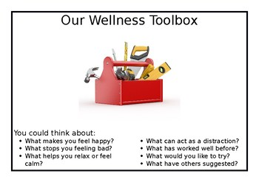

|  |  |
| --- | --- |
| **What makes you happy?** | **What has worked well before?** |
| **What helps you to relax or feel calm?** | **What would you like to try?** |
| **What can act as a distraction?** | **What have others suggested?** |

**What’s in your Wellness Toolbox**

**Optional Extras**

Think of things you could do once a day, week, month, year to make you feel better!

|  |  |
| --- | --- |
| **Daily** |  |
| **Weekly** |  |
| **Monthly** |  |
| **Yearly** |  |